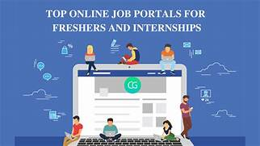

[Reflective Report on Online Job Portal]

[9/30/2021]

Submitted By:

Name: PERISHA GOLE

CU ID: 10791323

SOFTWARICA ID: 200092

GitHub link: https://github.com/softwarica-github/stw205cde-batch28ab-finalassignment-Peisha.git

video link:

[STW205CDE Developing The Modern web]

Perisha lama

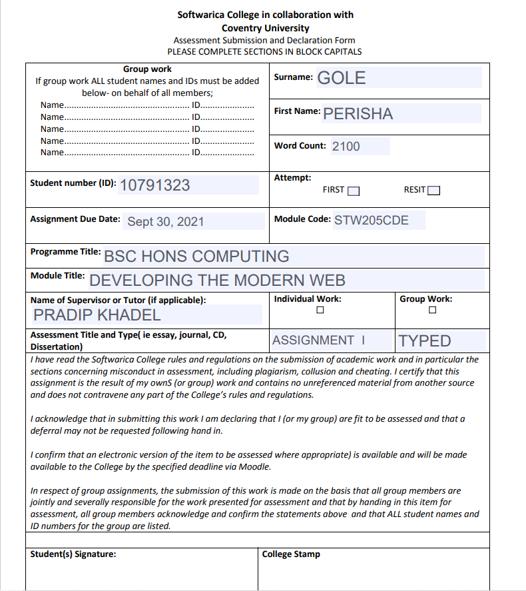



Table of Contents

Chapter 1 6

Introduction 6

Aim 7

Objectives 7

System Users 7

Features 8

Activities of Users 9

Chapter 2 10

Front end 10

Technologies 10

HTML: 10

Screenshots of frontend Code (HTML) 11

jQuery 25

Bootstrap 25

Significant of Responsive Design 26

Chapter 3 31

Database 31

Chapter 4 35

Back end 35

Technologies 35

Python 35

Django 36

37

Screenshots of Backend Code 37

Chapter 5 47

Project Issues 47

Limitation of Project 47

Future Work 48

Conclusion 49

References 50

Figure 1 Project Overview 4

Figure 2 Activities of User 7

Figure 3 HTML Logo 8

Figure 4 Index.html 9

Figure 5 Index.html Output 9

Figure 6 Contact.html 10

Figure 7 Contact.html Output 10

Figure 8 Footer.html 11

Figure 9 Footer.html Output 11

Figure 10 Admin Navigtaion.html 12

Figure 11 Admin Navigation.html Output 12

Figure 12 User_Login_Navigation.html 13

Figure 13 User_Login_Navigation.html Output 13

Figure 14 User_Profile.html 14

Figure 15 User_Profile.html Output Figure 16 Recruiter Login.html 14

Figure 17 Recruiter Login.html Output 15

Figure 18 Recruiter profile.html 16

Figure 19 Recruiter profile.html Output 16

Figure 20 CSS 17

Figure 21 CSS 1 17

Figure 22 CSS 2 18

Figure 23 CSS 3 18

Figure 24 CSS 4 18

Figure 25 CSS 5 19

Figure 26 JavaScript 20

Figure 27 JavaScript 1 21

Figure 28 JavaScript 2 21

Figure 29 JavaScript 3 21

Figure 30 JavaScript 3 22

Figure 31 JavaScript 4 22

Figure 32 JavaScript 5 22

Figure 33 jQuery 23

Figure 34 Bootstrap 23

Figure 35 Responsive Website 24

Figure 36 Desktop screen 25

Figure 37 Important links 25

Figure 38 Important dashboard 26

Figure 39 iPad Pro screen 26

Figure 40 iPhone X Screen 27

Figure 41 Templates 28

Figure 42 Database 30

Figure 43 Database 2 30

Figure 44 Student model 31

Figure 45 Job Model 31

Figure 46 Recruiter Model 32

Figure 47 Apply Job 32

Figure 48 Python 33

Figure 49 Django 34

Figure 50 Apps Install 35

Figure 51 Static 35

Figure 52 Index 36

Figure 53 Admin Login 36

Figure 54 user Login 37

Figure 55 Recruiter login 37

Figure 56 Recruiter Signup 38

Figure 57 User Home 38

Figure 58 Admin Home 39

Figure 59 View user 39

Figure 60 Admin home 39

Figure 61 recruiter Pending 40

Figure 62 Change Status 40

Figure 63 Admin Password Change 41

Figure 64 URLS 42

Figure 65 Projects 43

Figure 66 HTML Files 44

Figure 67 Live Chat 46





# Chapter 1

## Introduction

In the situation of the task, we are assigned to develop a web-based application. And I have developed the Online Job Portal Management System. In the era of technology, everybody wants the digital world where they don’t have to spend much time to complete the task as nowadays time is the most important thing. Therefore, because of technology people are trying to get knowledge of their jobs as well. Thus, in this system various company can post their job vacancy so that people can view the different kind of jobs opportunities and information related to interested company. This online job portal can end up being exceptionally useful since it permits clients of various profiles to transfer their CVs, look for jobs based on their capabilities. Each client can access through email and go after different positions all at once.

Figure 1 Project Overview

## Aim

The main aim of developing this website is to provide quality and effective job to the job seekers according to their qualification and experiences through digital world.

## Objectives

This task is pointed toward fostering a web-based search Portal for the Placement Details for work searchers.

* This system is a web-based application which can be run by anyone having valid login information.
* Job seekers can search for job through this web site.
* Job seekers login to this system to apply for the job by proving their CV and personal information.
* Recruiters signing in to this system to view the information of job applicants and select the one who have matched their expectation for the company goal.
* This system aware people regarding the modern technology and its benefits in our life.
* Admin manage all the recruiter’s information.
* Admin can view the total number of an employees ,employers, job apply and list of job of company through this web site.
* This system helps to grow the number of an employee’s application.

## System Users

* Admin
* Recruiter
* Users



## Features

* Signup as a user or as a recruiter.
* Login as user, recruiter, or admin.
* Contain particular dashboard for all users.
* Users can view job details, job list, edit information and can change profile picture.
* Users can apply for specific jobs according to their experience and qualification.
* All users can change their respective password.
* Recruiter can add, edit, and delete the job information.
* Recruiter is allowed to add users when admin accepts the request of the recruiter.
* Admin is allowed to select, reject and delete the recruiter.
* Admin is allowed to see the total number of users, recruiter, job apply and total jobs.
* Recruiter is allowed to edit and update details of the company and the profile.
* Admin and Recruiter can download the resume of the user.



## Activities of Users

Figure 2 Activities of User

# Chapter 2

## Front end

## Technologies

In this online system the following front-end has been used;

### HTML:

Markup language intensely used for making web pages and web applications. It was intended for this particular reason, and all internet browsers are worked to decipher HTML and render the substance in a program window.



Figure 3 HTML Logo



### Screenshots of frontend Code (HTML)

Figure 4 Index.html

Figure 5 Index.html Output

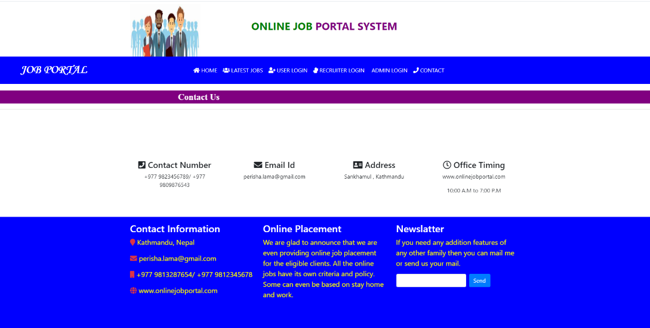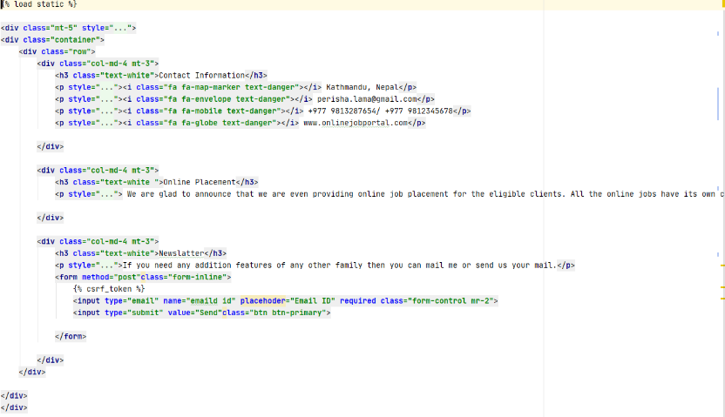 Figure 6 Contact.html

Figure 7 Contact.html Output



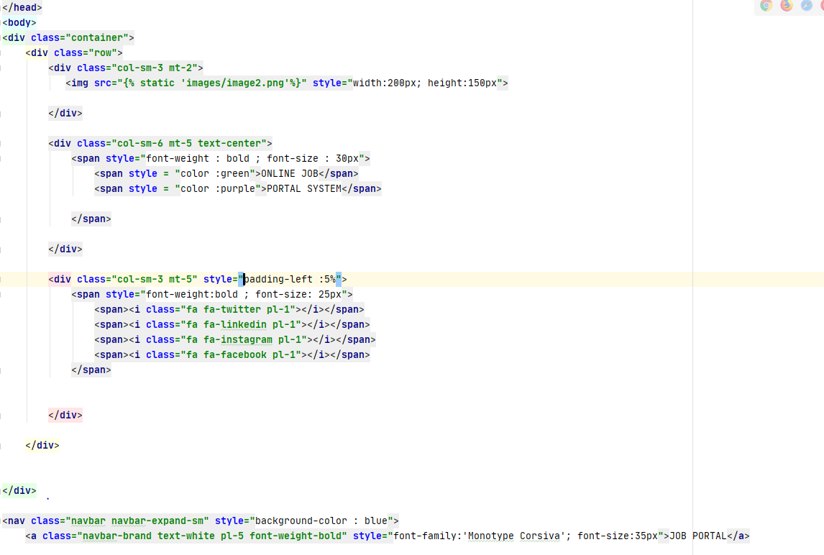 Figure 8 Footer.html



Figure 9 Footer.html Output



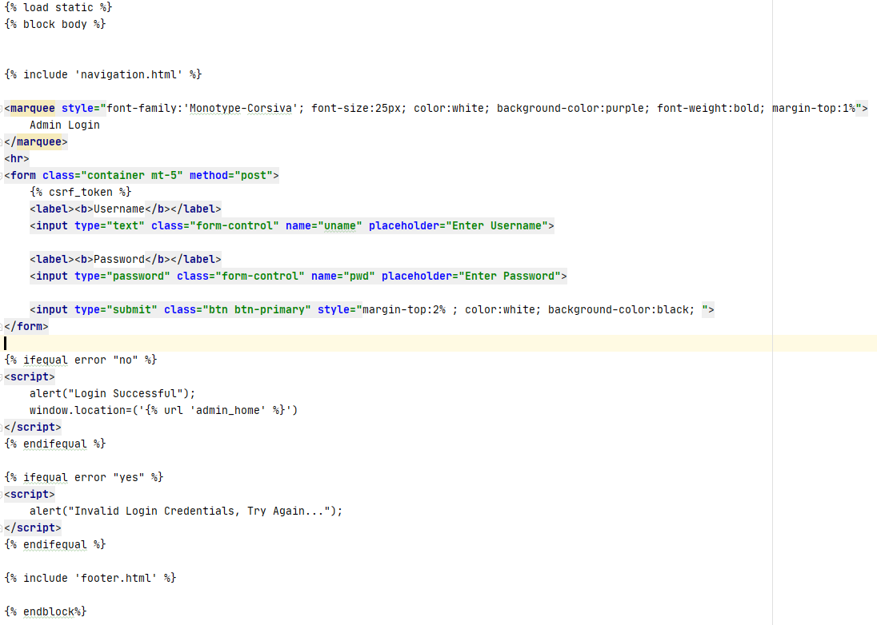

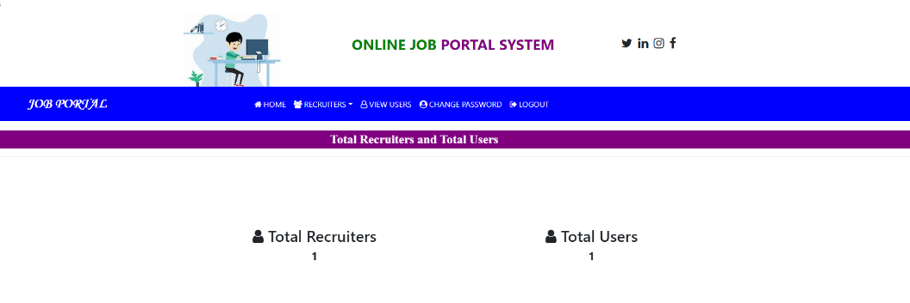 Figure 10 Admin Navigtaion.html

Figure 11 Admin Navigation.html Output

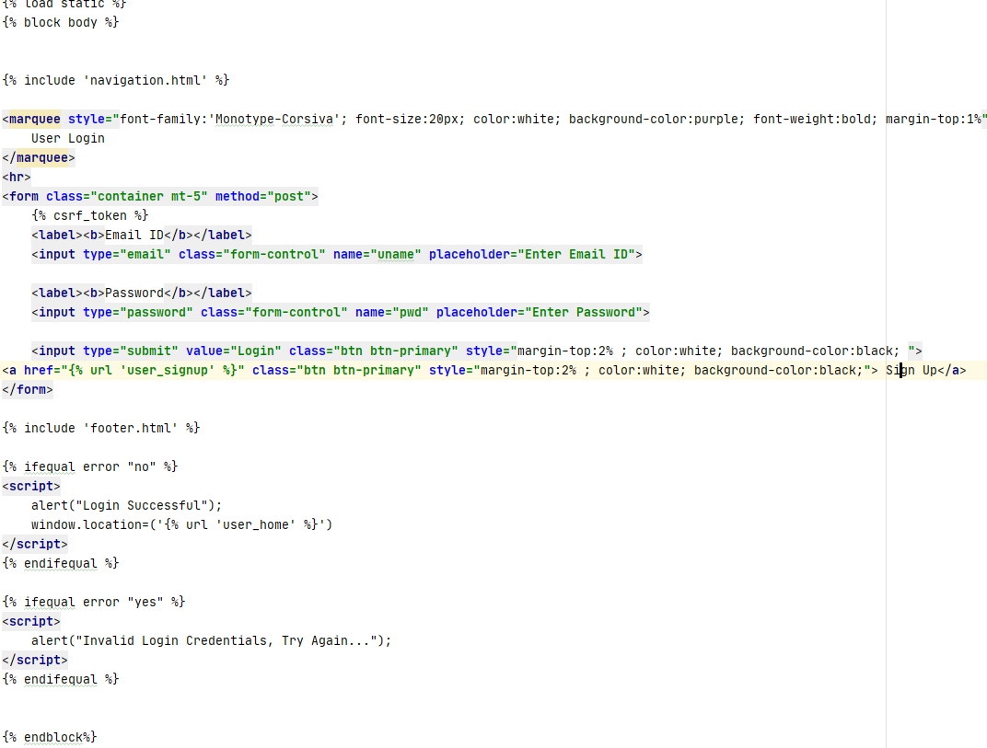



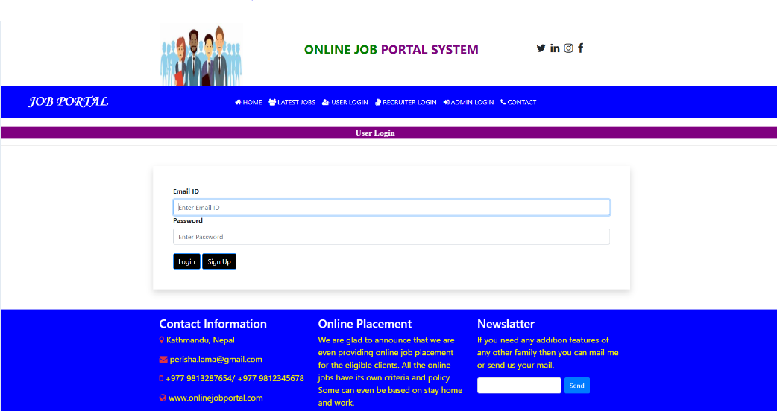 Figure 12 User_Login_Navigation.html

Figure 13 User_Login_Navigation.html Output

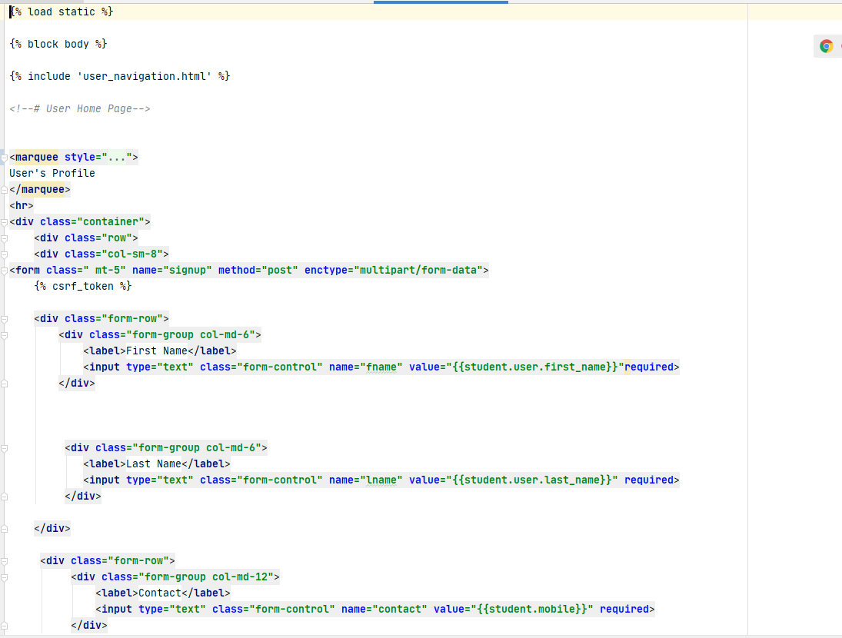 Figure 14 User_Profile.html

Figure 15 User_Profile.html Output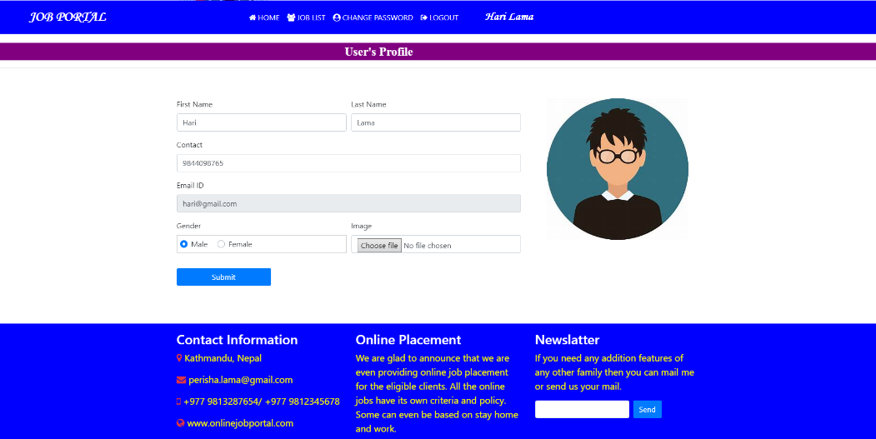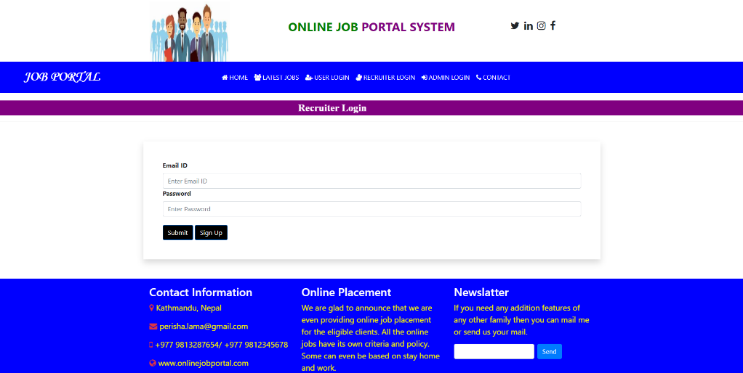 Figure 16 Recruiter Login.html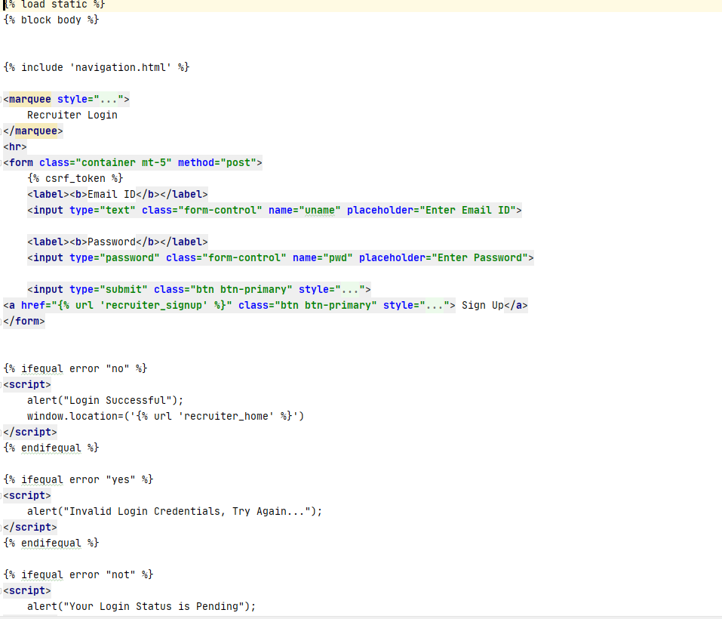

Figure 17 Recruiter Login.html Output

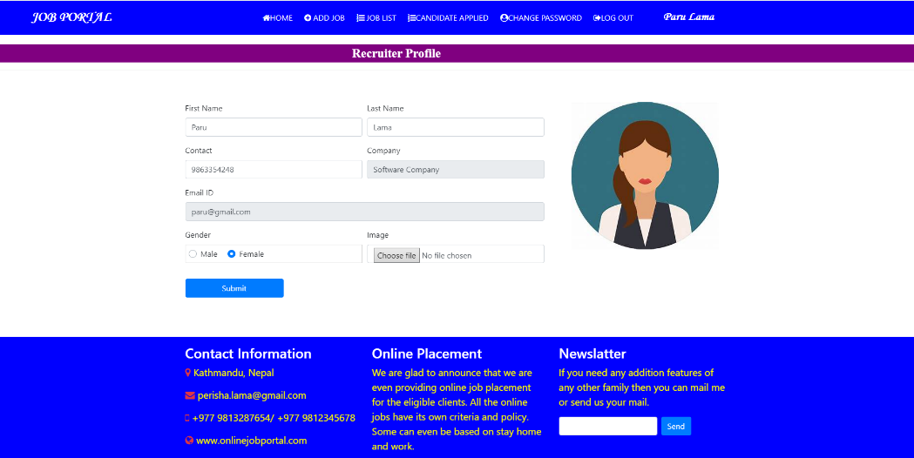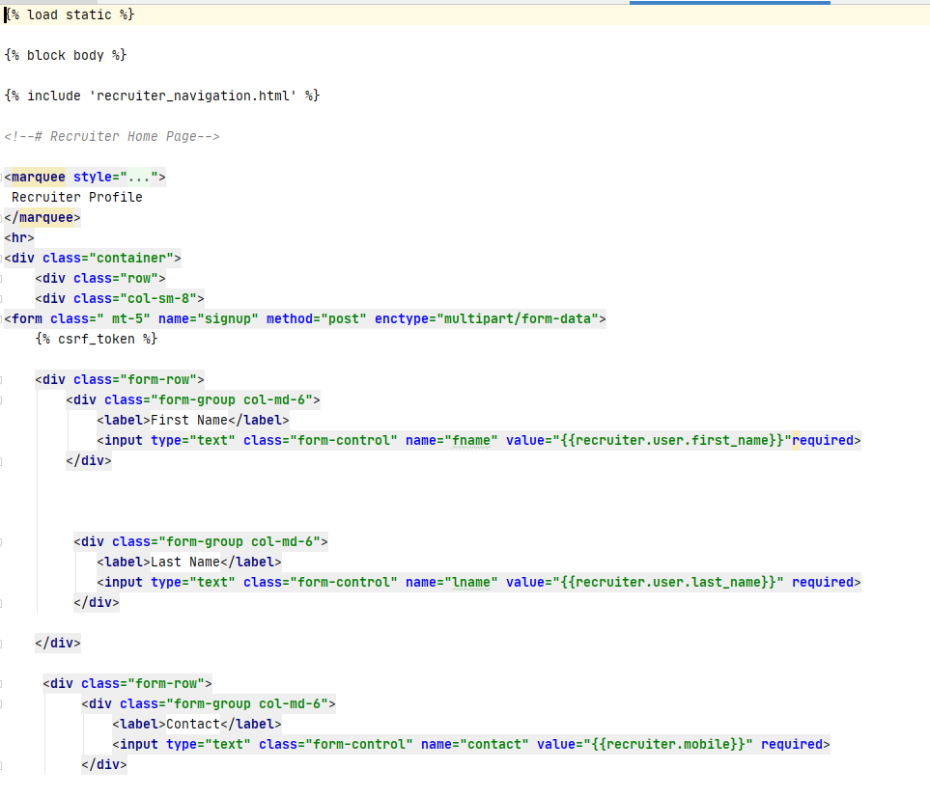 Figure 18 Recruiter profile.html

Figure 19 Recruiter profile.html Output



CSS:

Basic plan language is expected to improve on the method involved with making pages respectable. CSS is utilized to control the look and feel of the substance written in HTML.

Figure 20 CSS

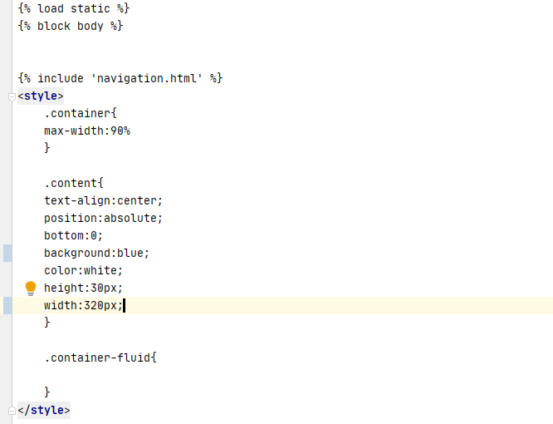Screenshots of CSS Code

Figure 21 CSS 1

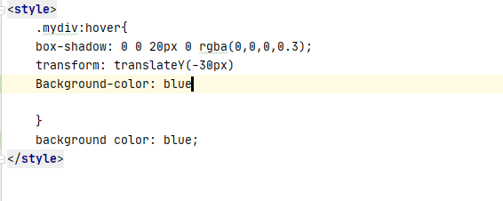

Figure 22 CSS 2

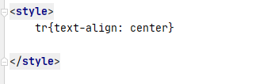

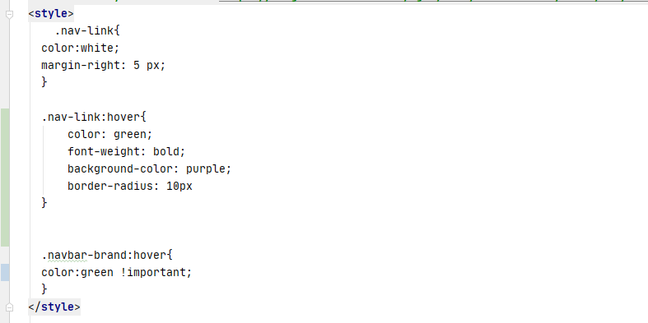 Figure 23 CSS 3

Figure 24 CSS 4

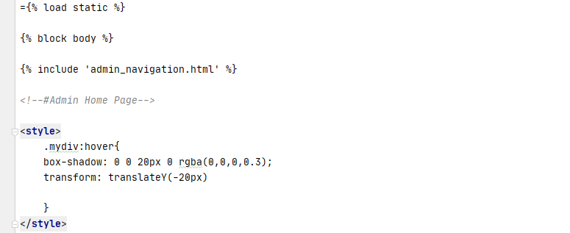 Figure 25 CSS 5



JavaScript

Dynamic programming language. It permits us to execute dynamic provisions on pages that is impossible with just HTML and CSS.



Figure 26 JavaScript

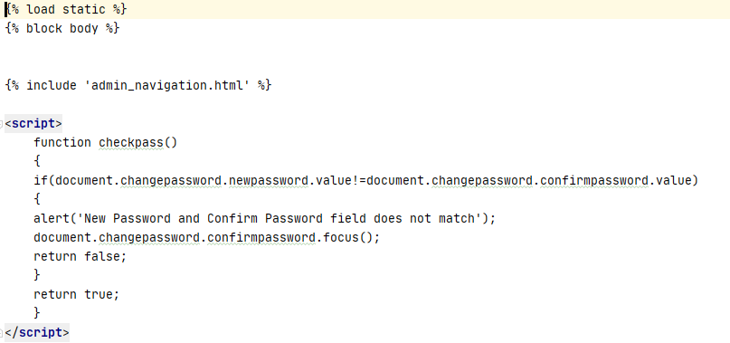Screenshots of JavaScript Code

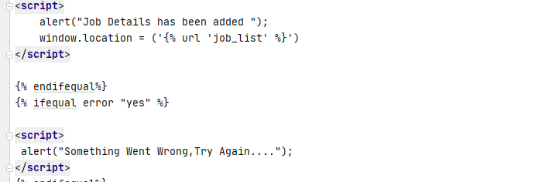 Figure 27 JavaScript 1

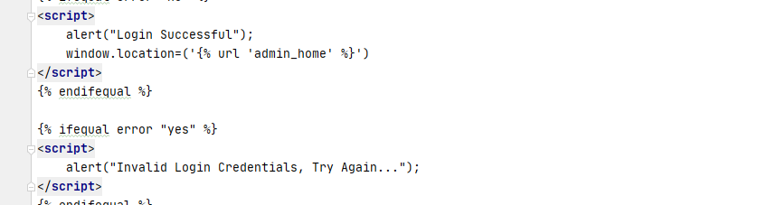 Figure 28 JavaScript 2

Figure 29 JavaScript 3

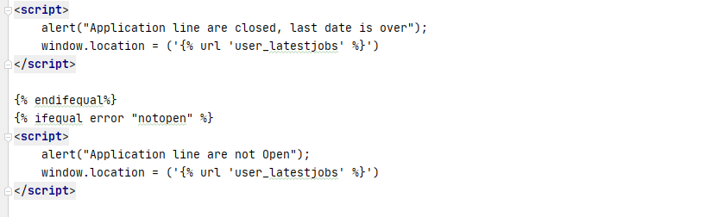 Figure 30 JavaScript 3

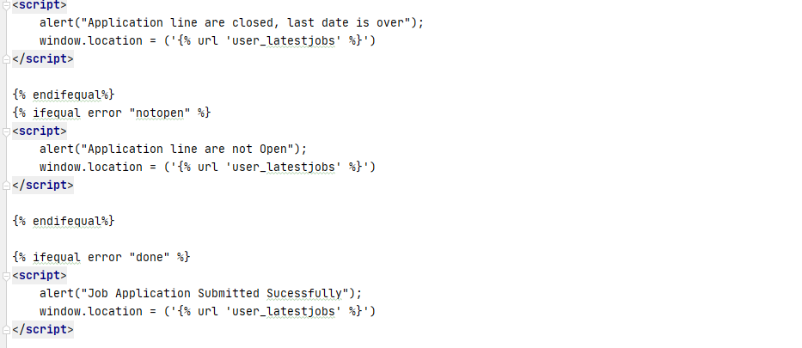

Figure 31 JavaScript 4

Figure 32 JavaScript 5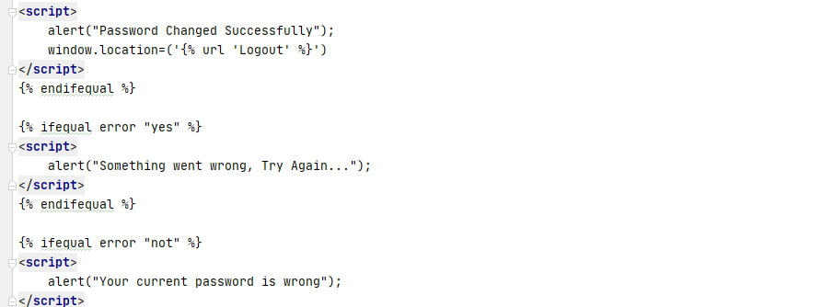

### jQuery

jQuery is a cross-stage JavaScript library expected to enhance the client side setting up HTML. jQuery is free, open-source programming, approved under the MIT License.

Figure 33 jQuery 

### Bootstrap

 Bootstrap is an open-source JavaScript structure made by the gathering at Twitter. It is a blend of HTML, CSS, and JavaScript code planned to help with building UI parts. It was furthermore modified to help both HTML5 and CSS3 and it is a free grouping of instruments for making locales and web applications.

Figure 34 Bootstrap

## Significant of Responsive Design

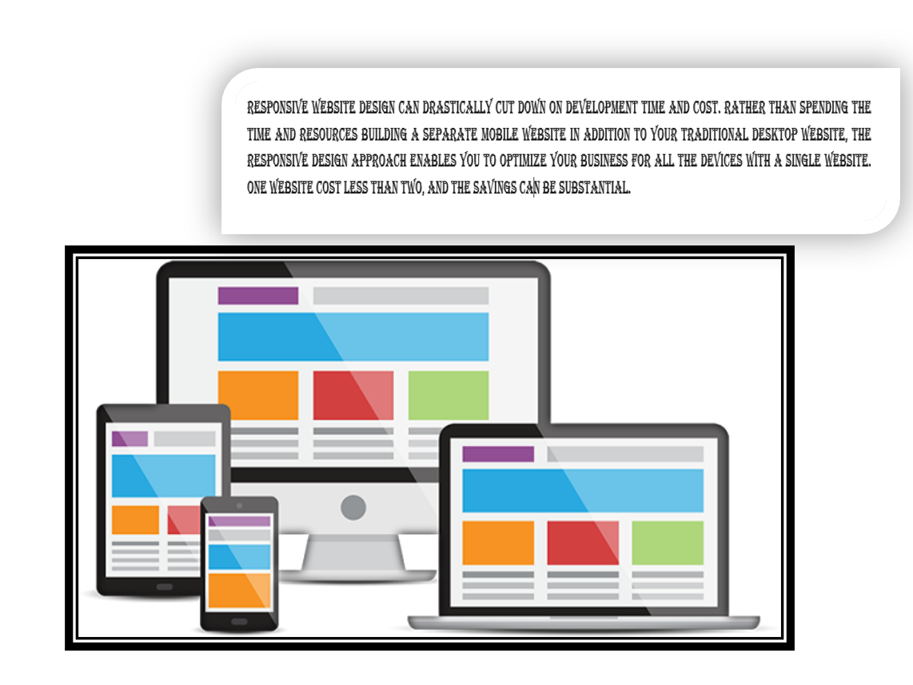Website composition is the current 'large thing' in the website composition industry. And Responsive web composition is a process for making a site that is acceptable or works completely on all gadgets. It additionally implies making a site that naturally scales its substance to squeeze into the client's current circumstance, this could be founded on clients' gadget screen size, gadget direction, and gadget stage. It makes the site content amicable which is vital on the grounds that it gives a decent client experience and makes a decent impact on forthcoming clients. It serves to Improved User Experience, increase in Mobile Traffic Quicker Website Development, and Lower Bounce Rates.

Figure 35 Responsive Website

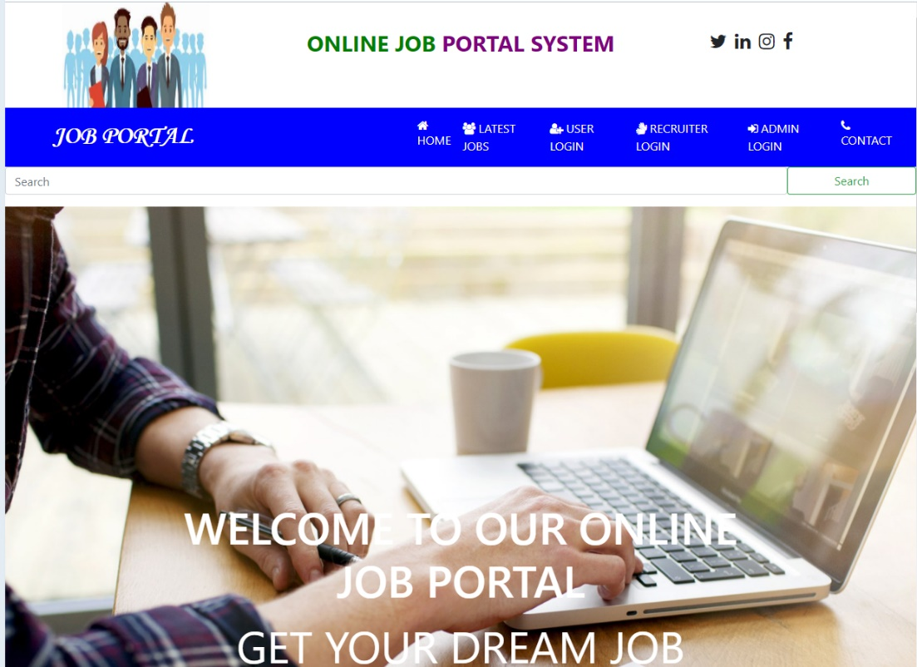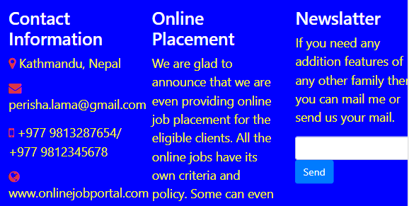 Figure 36 Desktop screen

Figure 37 Important links

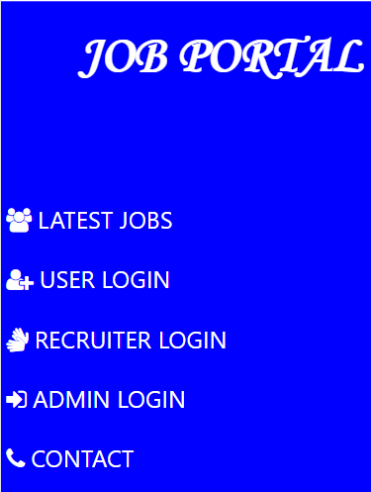

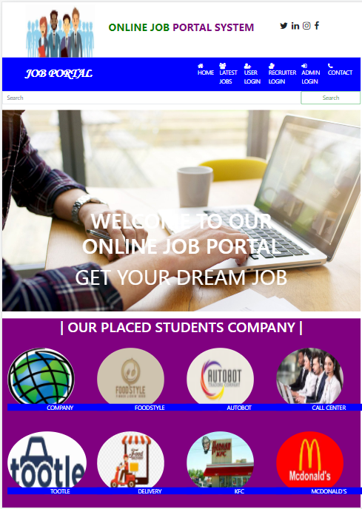 Figure 38 Important dashboard

Figure 39 iPad Pro screen

Figure 40 iPhone X Screen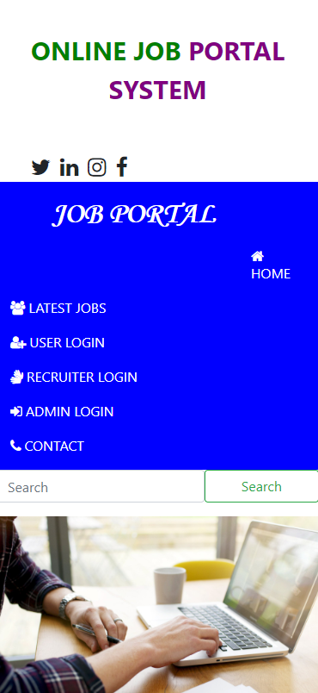



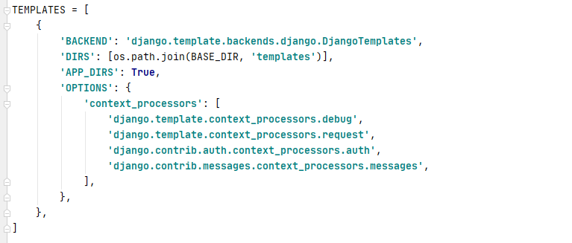

Figure 41 Templates

# Chapter 3

## Database

Database is put away as a document or a bunch of records that is set up for simple access, the executives, and refreshing. It separates data from the information base in light of inquiries. In this project I have used MySQL database.

MySQL is a database administration framework that is utilized to keep up with social information bases. It is an open-source programming sponsored by Oracle Corporation.

Its merits are:

1. It is widely adopted.
2. Easy to use.
3. Have effective and great performance.
4. It is an open-source software.
5. It is all around the world famous for being the most dependable and solid database.

Its demerits are;

1. MySQL doesn't uphold an extremely huge data set size as proficiently.
2. Exchanges are not dealt with effectively.
3. It experiences horrible showing scaling.
4. It is hard to scale.
5. Degrade performance.

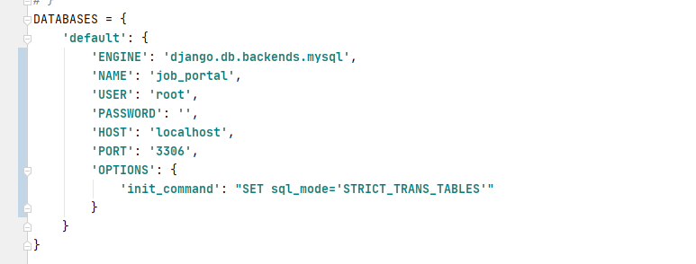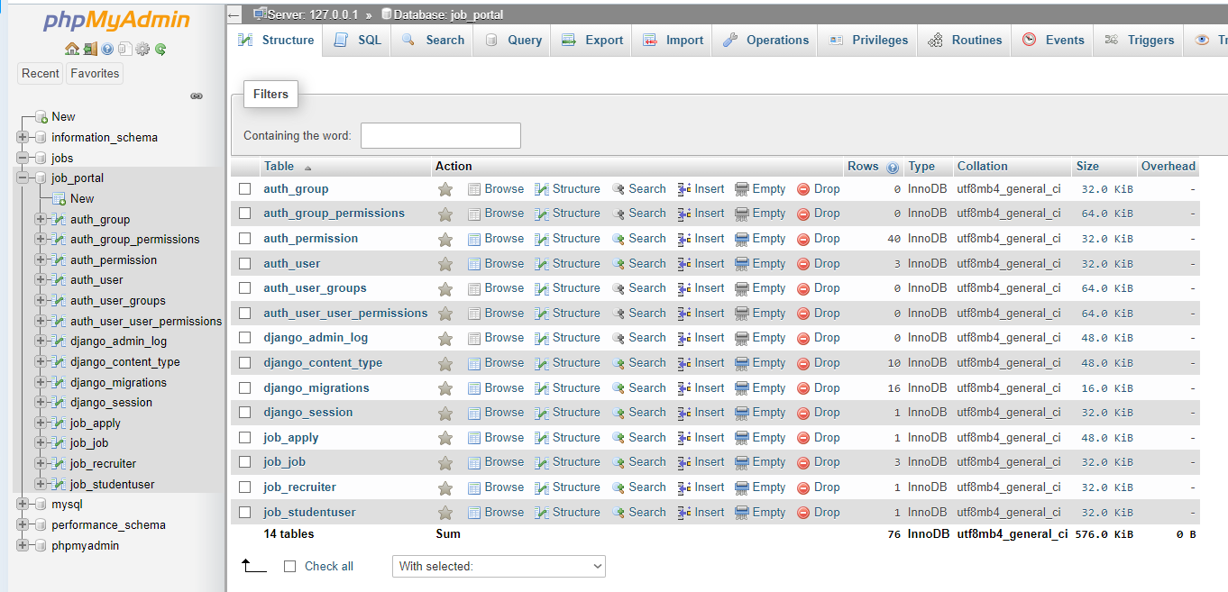 Figure 42 Database

Figure 43 Database 2

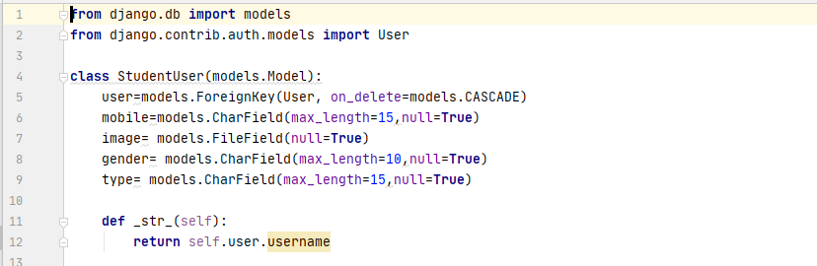

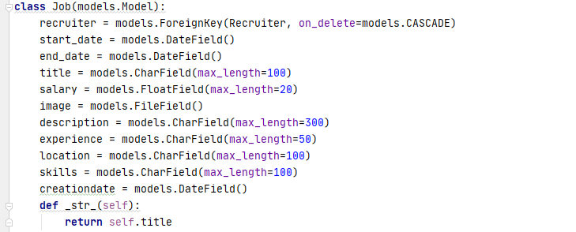 Figure 44 Student model

Figure 45 Job Model

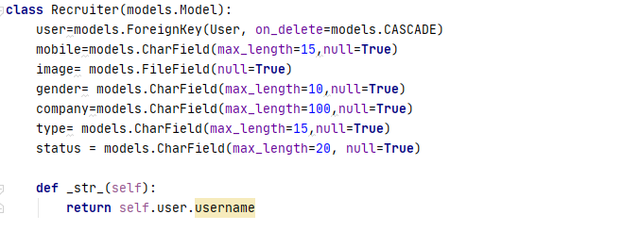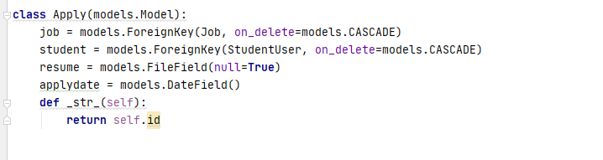 Figure 46 Recruiter Model

Figure 47 Apply Job

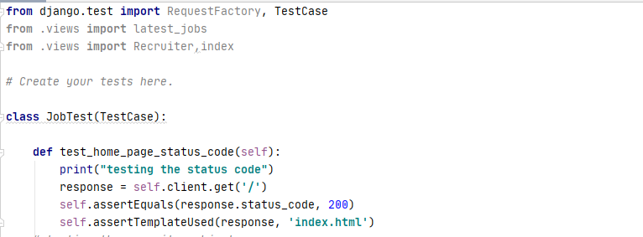Testing Screenshots

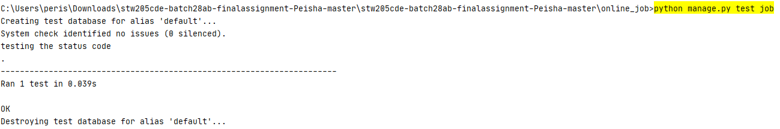 Figure 48 Testing 1

Figure 49 Testing 1 Output

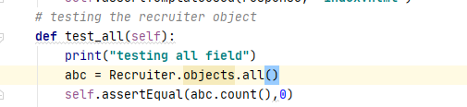

Figure 50 Testing 2

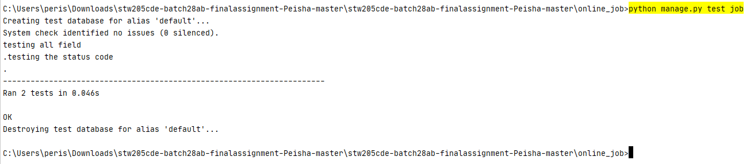

Figure 51 Testing 2 Output

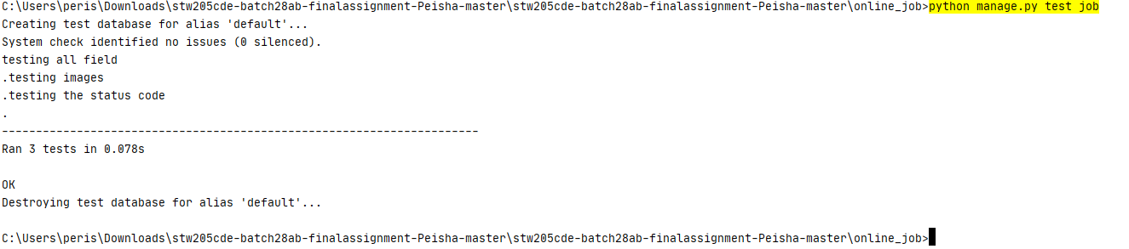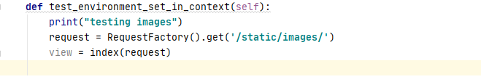 Figure 52 Testing 3

Figure 53 Testing 3 Output

# Chapter 4

## Back end

## Technologies

### Python

 Python is a well-known programming language that can be utilized on a worker to make web applications and can interface with information base frameworks. It has a basic linguistic structure like the English language and can even deal with enormous information and perform complex arithmetic. Web structures like Django and Flask rely upon Python. They help you with creating laborer side code which helps you with managing informational indexes, form backend programming reasoning, arranging URLs, etc.

Figure 54 Python

### Django

Django is a free and open-source web application framework, written in Python. moreover, it is an execution of the web frameworks thought. Additionally, a web framework is a lot of parts that help you with making locales speedier and more straightforward.

Figure 55 Django

## 

### Screenshots of Backend Code

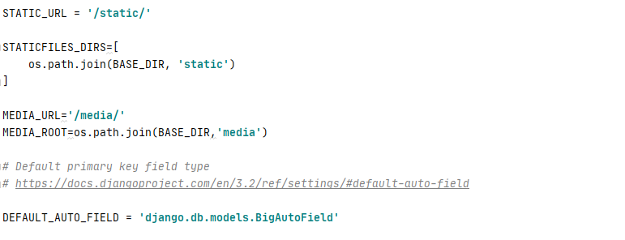 Figure 56 Apps Install

Figure 57 Static

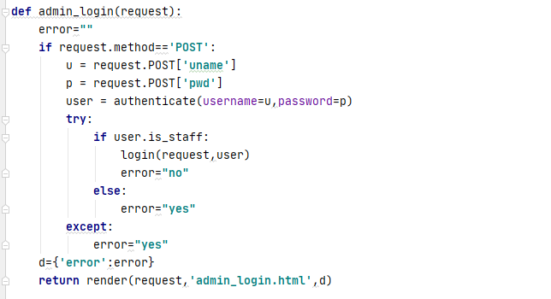 Figure 58 Index

Figure 59 Admin Login

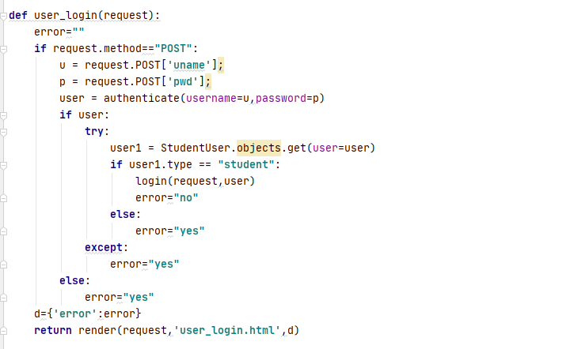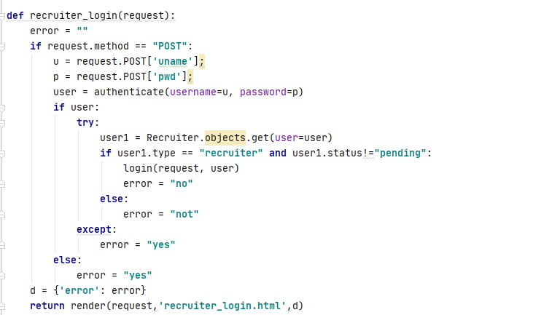

Figure 60 user Login

Figure 61 Recruiter login

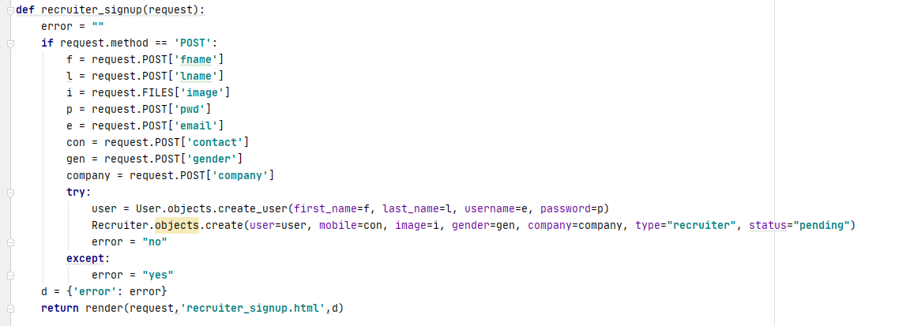

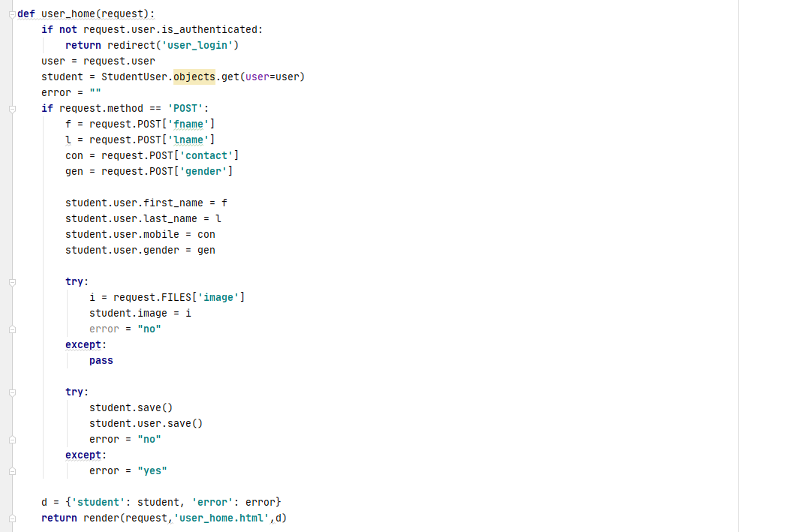 Figure 62 Recruiter Signup

Figure 63 User Home

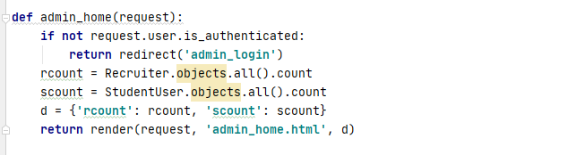

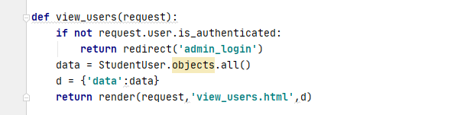 Figure 64 Admin Home

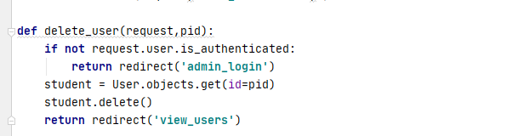 Figure 65 View user

Figure 66 Admin home



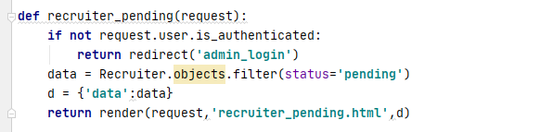

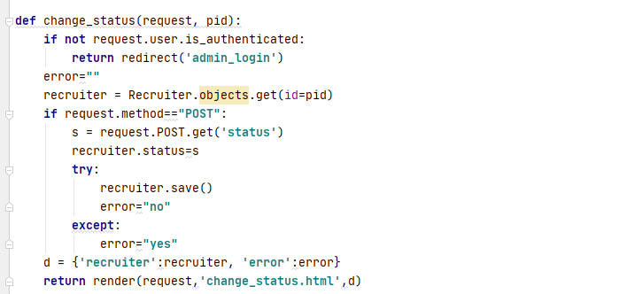 Figure 67 recruiter Pending

Figure 68 Change Status

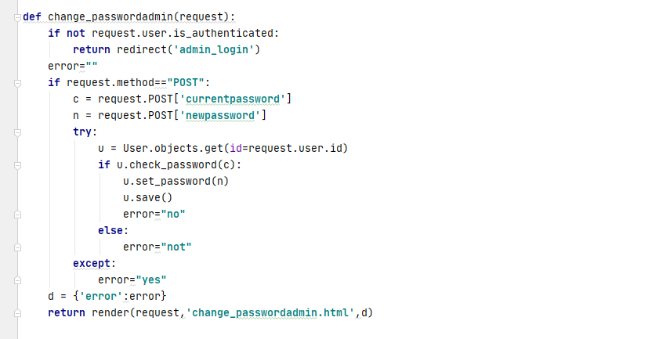 Figure 69 Admin Password Change



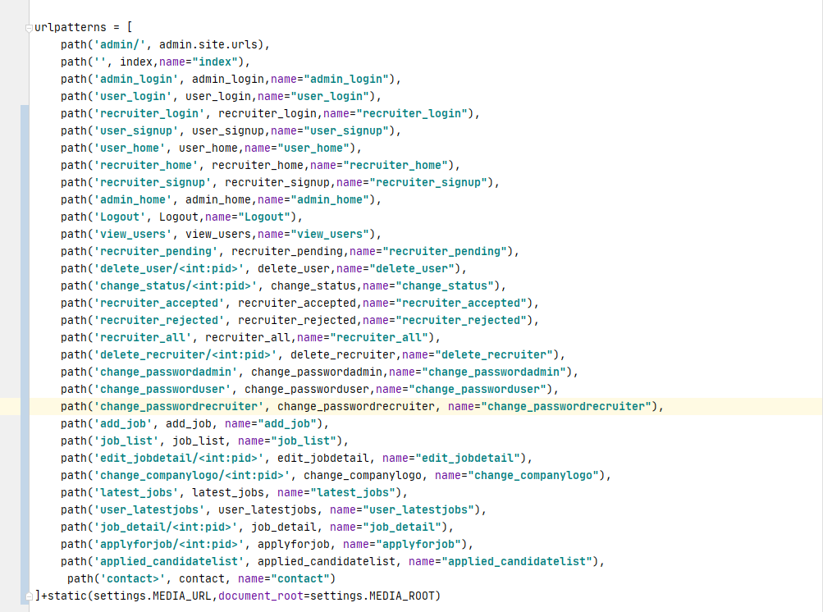 Figure 70 URLS



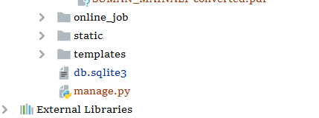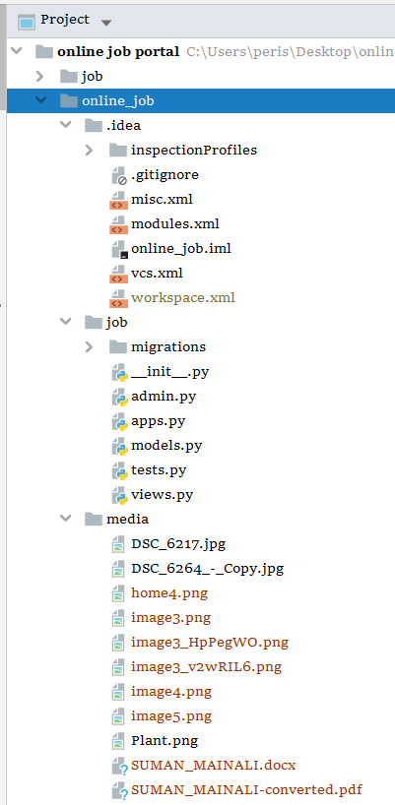 Figure 71 Projects



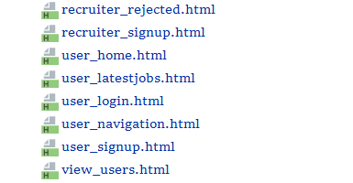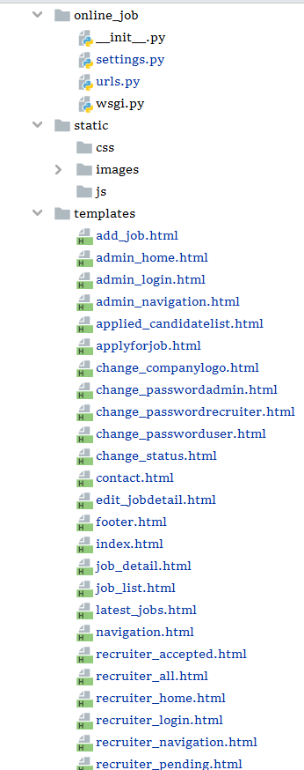 Figure 72 HTML Files





# Chapter 5

## Project Issues

1. Difficulty while installing MySQL client.
2. Unable to pass the data of recruiter in database.
3. Error occur while uploading the files of jobseeker in form.
4. Error while updating the information.
5. Error while connecting to database.

# Limitation of Project

Despite the fact that I have finished the advancement of site, it conveys certain absence of provisions which has been recorded underneath;

1. Insufficient dashboard for users.
2. Contain limited information.
3. Not familiar to the users who lack the knowledge of computer.
4. Need internet to run.
5. Recruiter cannot add or edit job until the admin accept the request.
6. Small scale system.
7. Limited features for users and recruiters.



# Future Work

1. Live chat conversation between users and website administrator.
2. Allow the work searchers for advanced channels.
3. Job cautions highlights.
4. Job saves include.
5. Advance Recruiter online occupation entrance highlights.

Figure 73 Live Chat



# Conclusion

Finally, this system doesn't ensure that you'll find a new line of work. It's basically an employment form apparatus that permits you to go after positions and interface with likely bosses and also contains the direct requesting for business. The standards of programming items were very much executed all through the framework. The entirety project goes through with brimming with excitement and with loaded with euphoric minutes. And the venture has been made according to the given determination. The framework has been made as easy to use as conceivable by the utilization of Django. That is the reason Management holds a significant spot in programming creation.

During the improvement of this project, I have dealt with numerous issues. To start with, I have utilized the Django Admin board for simple and quick outcomes but, when I attempt to associate the information base in MySQL it happens a great deal of mistakes in my undertaking. However, I didn't stop there I explored regards to the information base association and surprisingly observed a few instructional exercises lastly tackle the blunder and foster an effective successful Online Job Portal web site. Developing this web site has been really joyful to me and got the opportunities to learn many things which I was unknown about and even can utilize that knowledge in future projects.



# References

*What Is CSS?* (2021) available from <https://www.tutorialspoint.com/css/what_is_css.htm> [20 September 2021]

*What Is JavaScript? A Definition of The JS Programming Language* (2021) available from <https://www.freecodecamp.org/news/what-is-javascript-definition-of-js/> [20 September 2021]

*What Is Bootstrap? - Definition From Whatis.Com* (2021) available from <https://whatis.techtarget.com/definition/bootstrap> [20 September 2021]

Tim, C. (2021) *Sweet Alerts | Material Dashboard Dark @ Creative Tim* [online] available from <https://www.creative-tim.com/learning-lab/bootstrap/sweet-alerts/material-dashboard-dark> [20 September 2021]

*What Is Python? Executive Summary* (2021) available from <https://www.python.org/doc/essays/blurb/> [22 September 2021]

*Introduction To Python Programming Language* (2021) available from <https://beginnersbook.com/2018/01/introduction-to-python-programming/> [22 September 2021]

